Cold weather is here…Can you feel it in your bones?

Have you ever heard someone say “the weather is about to change, I can feel it in my bones”?

Growing up, I always thought this was an old wife’s tale, but it turns out there is some truth to it.

As many of us have been scrapping icy windscreens the past few days, and turning the heating up a notch, our bodies may be experiencing the changes caused by a few degrees drop in mercury.

Painful joints, stiffness, headaches and those all over deep aches are all too common over the winter months. But why does the temperature have an impact on our muscles and joints?

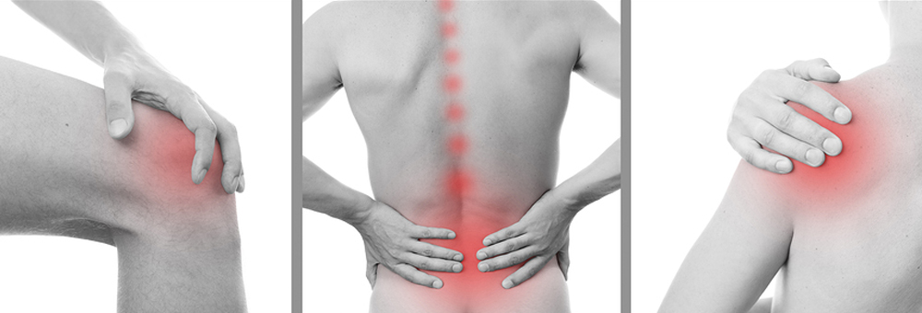

There may be a combination of elements at play.

Firstly, cold air will bring about a change in barometric pressure (the weight of the atmosphere that surrounds us) resulting in higher or lower pressure.
As the temperature drops, the cold air lowers barometric air pressure and causes gas and fluids to constrict. A similar effect is felt on our muscles.

Lower air pressure can cause the muscles to constrict and tighten which increases their mass and exerts more pressure on the joints those muscles attach to. This change may be at a microscopic level, but for those with chronic conditions, it feels more significant.

Another element that will have a major impact on how our body feels in colder weather is that of trigger points. My clients would have heard of these “knotty” horrors during sessions, as they are worked deeply. But may not realize that they are partially behind that sudden pain and tension they feel when the weather changes. Trigger points are what you may refer to as a knot…they are small pieces within the muscle that become stuck in a contracted state. The contracted fibres close down the nearby capilliaries that supply the localized fibres with nutrient rich, oxygenated blood.

If you were to clench your fist tightly you will see a similar thing; your fingers and knuckles become white as the blood is drawn away from those areas.

The contracted fibres, which can be as small as 2mm, are stuck. Blood flow is insufficient, muscle fibres are unable to get rid of water that normally builds up when you use your muscles and the nerves above which didn’t get the memo that the muscle was stuck, repeatedly tries to send contract signs until the nerve becomes sensitized and in response, signals PAIN! You may feel a deep ache, a burning stabbing sensation, muscle weakness and tingling as well as restricted painful movement.

That 2mm “knot” depending on its location, can be enough to cause pain that will radiate over the neck, should and arm!
In chronic pain conditions like Fibromyalgia, arthritis and polymyalgia, this can be enough to trigger a significant flare in their conditions.

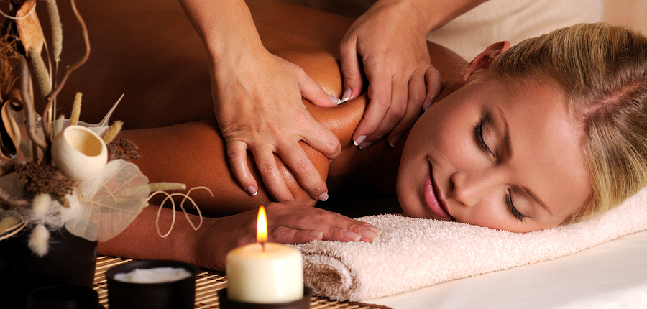

Is it time for a massage?

Luckily, regular massage over the winter months can make a huge difference. The deep, penetrating effect of massage will help release those contracted, tight muscles, instantly relieving pressure on the joints and improving range of motion.

Massage will increase circulation throughout the body, flushing those residual toxins and coupled with trigger point therapy, those radiating pains can be released.

In winter months, a healthy lymphatic system is important. Massage will increase the flow of lymph which will help stimulate the production of antibodies and white blood cells…our body’s defense system against infections and bacteria.

Massage is a great cure for the winter blues. Stress hormones can not only reduce our natural killer cells, our first line of defense for viruses, they also reduce our happy hormones like serotonin and dopamine. One massage has shown a 32% increase in serotonin. Interestingly, when serotonin levels are high, pain levels are reduced. So it sounds like a win, win, situation.

So keep your body fighting fit and pain free this winter, book a massage. Your body will thank you for it!

Click the Book Now!

Amanda Smith
Remedial Massage Therapist
Integrated Body
Papamoa

